InfoPharma Ordering System
IPOS – PU
Online Platform

Summary
This is a Requirements Specification and High-Level Design Document

Authors
Nuhur Mohammad

Contents
1. Preface 3
1.1 Purpose and scope of the document 3
1.2 Intended audience and Reading Suggestions 3
1.3 History of the document 3
2. Introduction 3
3. Glossary 4
4. System Requirements 5
4.1 Purpose and Scope of the System 5
4.2 Functional System Requirements 6
4.3 Non-Functional System Requirements 6
4.4 Assumptions and Constraints 6
4.5 Use Case Diagram 7
4.6 Use Case Speceifications 7
5. IPOS High-Level Design 8
5.1 IPOS-SA (Server Application) 8
5.2 IPOS-CA (Client Application) 8
5.3 IPOS-PU (Online Platform) 8

1. Preface

1.1 Purpose and scope of the document
This document is a Requirements Specification and High-Level Design document for IPOS-PU (Online Platform) subsystem. It serves as a proposal and technical blueprint for the Customer (Info Pharma Ltd) and the Team Project Management Team.
The document details the functional requirements of the IPOS-PU subsystem and the high-level software architecture for the entire InfoPharma Ordering System (IPOS). Which consists of three subsystems: IPOS-SA, IPOS-CA and IPOS-PU. While this document shows how these subsystems may interact via agreed interfaces it does not cover the internal implementation details of the IPOS-PU subsystem.

1.2 Intended audience and Reading Suggestions
The primary audience includes:
The Customer: Mr. Lancaster (CEO), Mr. Walter (CTO), and Mr. Khan (Head of IT)
Team Consultant: Ali Sarvghad Batn Moghaddam

1.3 History of the document
Version 1.0 Initial draft for the Week 5 deliverable (27 February 2026)

2. Introduction
InforPharma Ltd, a major pharmaceutical distributor, is transitioning from a traditional paper-based catalogue and moving on from the traditional phone/email ordering system to a modern B2B software application. The InfoPharma Ordering System (IPOS) is broken into three distinct subsystems, the server application (IPOS-SA), the client application (IPOS-CA), and the online platform (IPOS-PU).
The IPOS-PU is the online platform that allows a merchant to sell pharmaceuticals and beauty products directly to the public. Some key features include:
- Member Management: Registration for “commercial” customers (which is passed onto IPOS-SA for due diligence), and “non-commercial” customers
- Sales & Catalogue: Functionality for the customer to filter the products and to use a virtual shopping cart and pay via credit or with debit card or the integrated third-party services like PayPal
- Marketing: Tools for merchants to manage advertising and promotions campaigns with variable discounts
- Conversion Tracking: Monitoring the customer engagement through out their experience by tracking click rate and actual purchases to measure success

3. Glossary
Term | Definition
Actor | A human or external system interacting with the system, such as a Public Member or the IPOS-SA subsystem
B2B | Business-to-Business; refers to software designed for commercial interaction between companies.
CaptureService.com | A 3rd party service providing CAPTURE features to verify human users during registration
CSR | Centre for Software Reliability.
Conversion Rate | The ratio of items purchased to items clicked/included in an order during a promotion campaign.
Interface | A contract defining set abstract operations that a subsystem must provide or require for communication.
IPOS-CA | Client Application; used by merchants in their pharmacy shops to manage local stock and sales
IPOS-PU | The online platform used by merchants for direct sales of pharmaceutical goods to the public
IPOS-SA | Server Application; administered by InfoPharma to maintain the global catalogue and merchant accounts
SMTP | Simple Mail Transfer Protocol: an external service used to send automated emails
UML | Unified Modelling Language; the standard for documenting software development
Use Case | A basic interaction between a system and an actor.

4. System Requirements
This section describes the system requirements for the InfoPharma Ordering System (IPOS), with particular focus on the IPOS-PU subsystem. The requirements defined here specify what the system is expected to do, the constraints under which it operates, and the assumptions made at this stage of development. These requirements form the basis for the subsequent high-level design and interface specifications.

4.1 Purpose and Scope of the System
The purpose of IPOS is to provide an integrated software solution that supports the online and in-store sale of pharmaceutical and beauty products. The system is composed of multiple subsystems, each developed by a separate team, which must cooperate through well-defined interfaces.
The scope of IPOS-PU (Online Platform) includes:
- Enabling public (non-commercial) customers to browse products, place orders, and complete purchases online.
- Supporting commercial customers who require additional registration and approval before accessing certain services or pricing.
- Providing functionality for online sales, promotions, and customer engagement tracking.
- Communicating with other IPOS subsystems to verify customer status and ensure correct handling of inventory and order processing.
The system does not aim to replace in-store pharmacy operations; instead, it complements them by extending sales and customer interaction to an online platform.

4.2 Functional System Requirements
The following functional requirements describe the expected behaviour of the IPOS-PU subsystem at a high level.
IPOS-PU shall:
- Allow users to register as either non-commercial or commercial customers.
- Support the submission of commercial customer registration requests for verification.
- Enable users to browse, search, and filter the online product catalogue.
- Allow users to add products to a shopping cart and place orders.
- Support promotional features such as discounts or campaigns.
- Track customer interactions and sales data for reporting purposes.
Where necessary, IPOS-PU shall obtain external information or services from other IPOS subsystems via defined interfaces rather than implementing such functionality internally.

4.3 Non-Functional System Requirements
The IPOS system, including IPOS-PU, must satisfy the following non-functional requirements:
- Modularity: Each subsystem must be loosely coupled, interacting only through defined interfaces.
- Scalability: The online platform should be capable of supporting growth in the number of users and transactions.
- Maintainability: The system design should allow individual subsystems to evolve independently.
- Security: Customer data and commercial information must be handled securely, with access restricted according to user roles.
- Reliability: Subsystem failures should not compromise the integrity of the entire system.

4.4 Assumptions and Constraints
- The IPOS system consists of multiple subsystems developed independently by separate teams.
- Subsystems interact only through explicitly defined interfaces.
- The system operates without additional security or data-protection mechanisms.
- The system does not handle product returns or refunds.
- Network communication between subsystems is assumed to be available and reliable.

4.5 Use Case Diagram
This section presents the UML use case diagram for the IPOS-PU (Online Platform) subsystem. The internal implementation of IPOS-PU and the behaviour of other subsystems are outside the scope of this model.
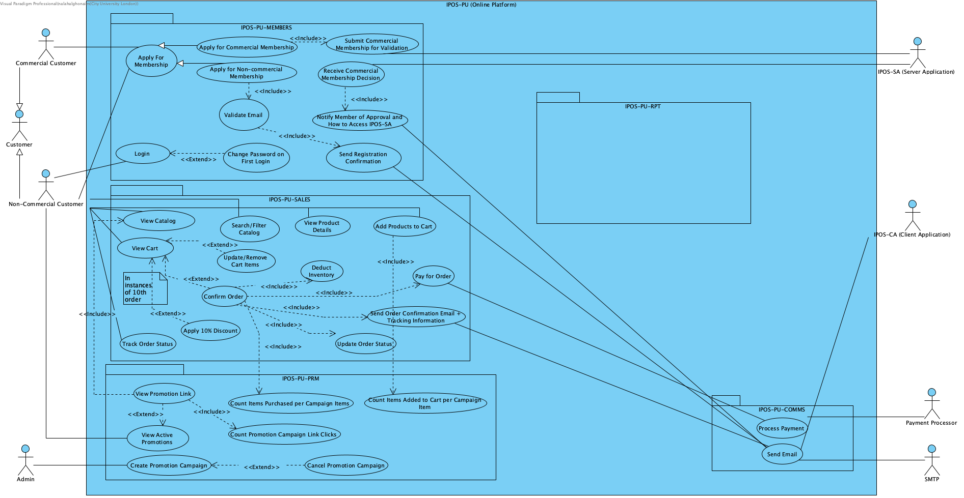

4.6 Use Case Speceifications
A set of simplified Use Case Specifications:

5. IPOS High-Level Design
This section defines the high-level design of the entire InfoPharma Ordering System (IPOS) software, which includes its software architecture, the subsystems IPOS is made up of, and the communication interfaces which allow these subsystems to interact. The IPOS architecture is modelled using UML component diagrams, in which each subsystem is represented as a component with stereotype <<subsystem>>.

The subsystems envisaged are:

5.1 IPOS-SA (Server Application)
IPOS-SA is the server-side subsystem administered by InfoPharma. It is responsible for the global management of product catalogue and merchant-related data, and for server-side services needed to support both the pharmacy client application and the online platform. In particular, IPOS-SA supports due-diligence and approval processes for commercial customers/merchants, and provides services and data needed by the other subsystems to operate reliably and consistently.

5.2 IPOS-CA (Client Application)
IPOS-CA is the client application used by merchants in their pharmacy shops. It supports in-store operations related to sales and stock handling, including maintaining or interacting with local inventory/stock information needed to fulfil orders. The client application must communicate with IPOS-SA and (where required) the online platform to ensure that catalogue and inventory-related operations remain consistent across the system.

5.3 IPOS-PU (Online Platform)
IPOS-PU is the online platform that allows a merchant to sell pharmaceutical and beauty products directly to the public. Key functional areas of IPOS-PU include:
- Member management: registration of commercial and non-commercial customers, including the submission of commercial registrations for verification via IPOS-SA.
- Sales and catalogue: browsing/filtering products, shopping cart management, checkout, and order placement.
- Marketing: promotion and campaign management (e.g., discount rules) and tracking user engagement.
- Conversion tracking and reporting: monitoring customer engagement and purchases, and generating administrative reports.
Internally, IPOS-PU may be organised into managers responsible for the main areas of functionality (e.g., membership, sales, communications, promotions, reporting), but detailed internal design is outside the scope of this deliverable and will be developed later.

